South China University of Technology
《Operation System》Experiment Report
Experiment Title： Session 3
Name： 陈宇勋 Student ID： 202230430026
Class： 22计科全英创新班 Group： None
Collaborator： None
Teacher： 钟竞辉
Description
【Objective and Requirement】
Implement a simple command interpreter in Linux. The interpreter should:
1) support both internal and external commands, and internal commands support two (cd, exit);
2) able to save 10 historical commands
The following system calls can be used to implement the interpreter:
1) fork() —create a new process;
2) execve() —Load a new program and execute it;
3) wait() —waiting for child process to exist
4) chdir() —change the working direction of a process.
【Environment】
Operating System：Linux;
Content
【Procedure】
1. Step：In task, I create a python file to satisfy the requirement. In these python files, I use modules “os”, “sys” to realize the function.
In my python file, function “execute_command(command)” will realize the function of this task. When this python file starts running, for each input line, there will should the current directory and “>>>” to notice users to input their commands. Three commands are available: ①cd directory_to_open, get into the specific directory ②history, show 10 commands recently ③exit, end this file.
Then I run each file in Ubuntu24.04, and obtain the following results.
2. Results：
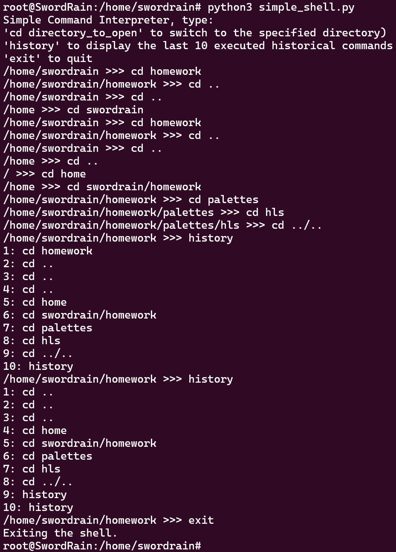
Conclusion
In this experiment, I have learned how to realize “cd”, “history” and “exit” command in Linux with Python, which is a simple but important command.
Teacher’s Comments and Score
Comment：

Score： Signature：
Date：
Appendix: Python Code
simple_shell.py
import os
import sys
history = []

def execute_command(command):
global history
if command.strip():
history.append(command)
if len(history) > 10:
history.pop(0)
args = command.split()
if not args:
return
if args[0] == "exit":
print("Exiting the shell.")
sys.exit(0)
elif args[0] == "cd":
try:
os.chdir(args[1])
except IndexError:
print("cd: missing argument")
except FileNotFoundError:
print(f"cd: no such file or directory: {args[1]}")
return
elif args[0] == "history":
for i, cmd in enumerate(history, start=1):
print(f"{i}: {cmd}")
return
try:
pid = os.fork()
if pid == 0:
try:
os.execvp(args[0], args)
except FileNotFoundError:
print(f"{args[0]}: command not found")
sys.exit(1)
else:
os.wait()
except OSError as e:
print(f"Fork failed: {e}")

def main():
print("Simple Command Interpreter, type:"
"\n'cd directory_to_open' to switch to the specified directory)"
"\n'history' to display the last 10 executed historical commands"
"\n'exit' to quit")
while True:
try:
command = input(f"{os.getcwd()} >>> ")
execute_command(command)
except EOFError:
print("\nExiting the shell.")
break
except KeyboardInterrupt:
print("\nUse 'exit' to quit the shell.")

if __name__ == "__main__":
main()

